LOGICAL FUNTIONS
NOTE: These functions can apply on “New column”.
Input Data:
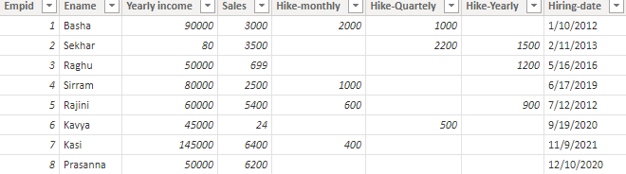

- IF: IF function is used to check the given expression is True or False.
Syntax: IF(<logical test>, <value_if_true>[, <value_if_false>])
NOTE: It returns only single statement.
In this return statement datatypes should be same.
//Dax Function: If = IF(Emp_Sales[Sales] > 3000, "Good", "Bad")
Output:
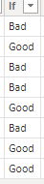

2)AND: This function checks two expressions.
NOTE: This function accepts two arguments, if the both the conditions are true, then it returns True, otherwise it returns false.
AND allows only 2 conditions we want go multiple conditions then will go to use the operator is “&&” otherwise use “AND” operator.
Syntax: 1) AND(<logical1>,<logical2>)
- (<logical1>&&<logical2>&&<logical3>&&<logical4>&&<logical5>&&<logical6>….)
Dax Function: IFand = IF(AND(Emp_Sales[Sales] > AVERAGE(Emp_Sales[Sales]),
Emp_sales[Yearly income] >= 50000), "Good Job", "Bad Job")

Output:
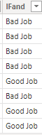
3)OR: This function checks two expressions.
NOTE: This function accepts two arguments, If the both the conditions are false, then it returns False, otherwise it returns True.
OR allows only 2 conditions we want go multiple conditions then will go to the operator is “||” otherwise use “OR” operator.
Syntax: 1) OR(<logical1>,<logical2>)
2)(<logical1>||<logical2>||<logical3>||<logical4>||<logical5>||<logical6>….)

Dax Function: IFor = IF(OR(Emp_Sales[Sales] < AVERAGE(Emp_Sales[Sales]),
Emp_sales[Yearly income] >= 80000), "Watch List", "Doing Good")

Output:

4)NOT: This function converts True to False and False to True. I mean, it acts like a “Notequal(<>)”
Syntax: NOT(<logical>)
NOTE: In this we can use only one condition.
Dax Function Ifnot = NOT(IF(Emp_sales[Sales]>2000,TRUE(),FALSE()))

Output:
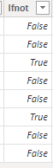
5)TRUE: This function returns logical True. If the condition is true, it will return True, otherwise it will return false.
Syntax: TRUE()
NOTE: It will same as IF Condition, but only difference is return statement. In if Function we can mention return value as per our requirement but in TRUE function, we can’t mention any return statement as per our wish.
Dax Function: True = IF(Emp_sales[Sales]>AVERAGE(Emp_sales[Sales]),TRUE(),FALSE())
Output:
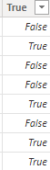
6) FALSE: This function returns logical False. If the condition is false, it will return false, otherwise it will return true.
Syntax: FALSE()
NOTE: It will same as IF Condition, but only difference is return statement. IN if Function we can mention return value as per our requirement but in FALSE function, we can’t mention any statement.
Dax Function: False = IF(Emp_sales[Sales]>AVERAGE(Emp_sales[Sales]),FALSE(),TRUE())

Output:
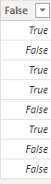
7)IFERROR: It simply performs the calculation and returns the results, if there is any error, then it returns the value inside the second argument.
Syntax IFERROR(value, value_if_error)
NOTE: It is very useful to handle the any errors.
Dax Function: Iferror = IFERROR(Emp_sales[Sales]/0,0)
Output:
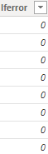
8)SWITCH: This function helps you to return multiple options.
Syntax: SWITCH(<expression>, <value>, <result>[, <value>, <result>]…[, <else>])
NOTE: 1) If we want go multiple returns statement then will go to this function.
2)All result expression and the else statement must be same datatype.
3) IF function returns TRUE or FALSE but in switch case returns multiple results.
4) In Switch case, If we need expression, can mention expression otherwise use TREUE ().
Dax function: Switch = SWITCH(TRUE(),
MONTH(Emp_sales[Hiring-date])= 1, "January",
MONTH(Emp_sales[Hiring-date])=2, "February",
MONTH(Emp_sales[Hiring-date])= 3, "March",
MONTH(Emp_sales[Hiring-date])=4, "April",
MONTH(Emp_sales[Hiring-date])= 6, "June",
MONTH(Emp_sales[Hiring-date])= 9, "September",
MONTH(Emp_sales[Hiring-date])=11, "November",
"Unknown")
Output:
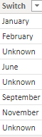
9)COALSESCE: It returns not null values. This function accepts multiple columns.
Syntax: COALESCE(<expression>, <expression>[, <expression>]…)
NOTE: It returns the first argument that is not BLANK. If the first argument is BLANK, it reruns the values provided by the expression in the second argument, up to last condition this will be done. If all the arguments are BLANK then it will be return as BLANK.
Dax Function: Coalesce = COALESCE(Emp_sales[Hike-monthly],Emp_sales[Hike-Quartely],Emp_sales[Hike-Yearly])
Output: 